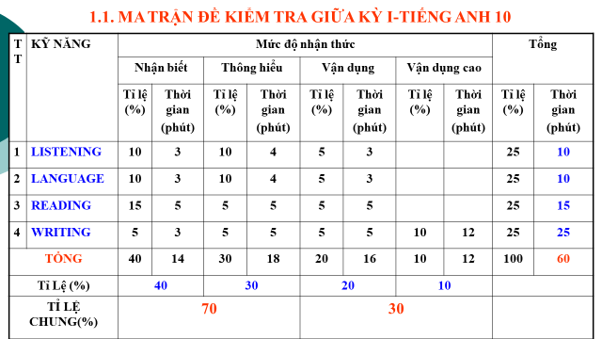
TEST SPECIFICATION: MID- FIRST- TERM TEST –ENGLISH 10- GLOBAL SUCCESS
School Year: 2022-2023
Questions | TESTED CONTENTS | LEVELS |  |  |  |  | NOTES
Questions | TESTED CONTENTS | Knowledge | Understanding |  | Application | High Application
1 | Multiple Choice  (Listening) | X |  |  |  |  | Level A2
2 | Multiple Choice  (Listening) | X |  |  |  |  | Level A2
3 | Multiple Choice  (Listening) |  | X |  |  |  | Level A2
4 | Multiple Choice  (Listening) |  | X |  |  |  | Level A2
5 | Multiple Choice  (Listening) |  |  |  | X |  | Level A2
6 | True- False  (Listening) | X |  |  |  |  | Units 1-2
7 | True- False  (Listening) | X |  |  |  |  | Units 1-2
8 | True- False  (Listening) |  | X |  |  |  | Units 1-2
9 | True- False  (Listening) |  | X |  |  |  | Units 1-2
10 | True- False  (Listening) |  |  |  | X |  | Units 1-2
11 | Stress | X |  |  |  |  | Stress in two -syllable words  (in Units 1, 2 & 3)
12 | Stress | X |  |  |  |  | Stress in two -syllable words  (in Units 1, 2 & 3)
13 | Vocabulary | X |  |  |  |  | Word meaning
14 | Vocabulary | X |  |  |  |  | Collocation/ Preposition
15 | Vocabulary | X |  |  |  |  | Word meaning
16 | Vocabulary |  | X |  |  |  | Word form
17 | Vocabulary |  |  |  | X |  | Collocation/ Preposition
18 | Grammar | X |  |  |  |  | Present simple/ Present continuous
19 | Grammar |  | X |  |  |  | Will/ Be going to
20 | Vocabulary/  Synonym/ Antonym |  |  |  | X |  | Root words in the text
21 | Cloze Text  (Level A2) | X |  |  |  |  | Word form
22 | Cloze Text  (Level A2) | X |  |  |  |  | Relative pronoun
23 | Cloze Text  (Level A2) |  |  | X |  |  | Word meaning
24 | Cloze Text  (Level A2) |  |  | X |  |  | Preposition
25 | Cloze Text  (Level A2) |  |  |  | X |  | Connectors
26 | Reading comprehension  (Level A2) | X |  |  |  |  | Getting details
27 | Reading comprehension  (Level A2) |  |  | X |  |  | Reference (Pronoun)
28 | Reading comprehension  (Level A2) | X |  |  |  |  | Getting details
29 | Reading comprehension  (Level A2) |  |  | X |  |  | Vocabulary
30 | Reading comprehension  (Level A2) |  |  |  | X |  | Main idea
31 | Error Identification | X |  |  |  |  | Present simple/ present continuous/
32 | Error Identification | X |  |  |  |  | To Infinitive/ bare-Infinitive
33 | Transformation |  |  | X |  |  | Passive Voice (Past simple)
34 | Transformation |  |  | X |  |  | To Infinitive/ Bare-Infinitive
35 | Transformation |  |  |  | X |  | Tenses (Present simple)
36 | Transformation |  |  |  | X |  | Collocation
 | Theme writing |  |  |  |  | X | A paragraph (environment improvements/ family routines)
TOTAL |  | 16 |  | 12 | 8 | One Writing

